Jerova vas (Avtor: Petra Humar)
The village of Jerova vas (Author: Petra Humar)
1.
SLO: Nekoč je živela šivilja, ki se je iskala kraj, v katerem bi živela in delala. Prišla je tudi v našo vas pa nas je vprašala, zakaj se Jerova vas imenuje tako kot se.
ENG: Once upon a time a dressmaker was looking for a place to live and work. She came to our village and asked if we know how our village got its name.
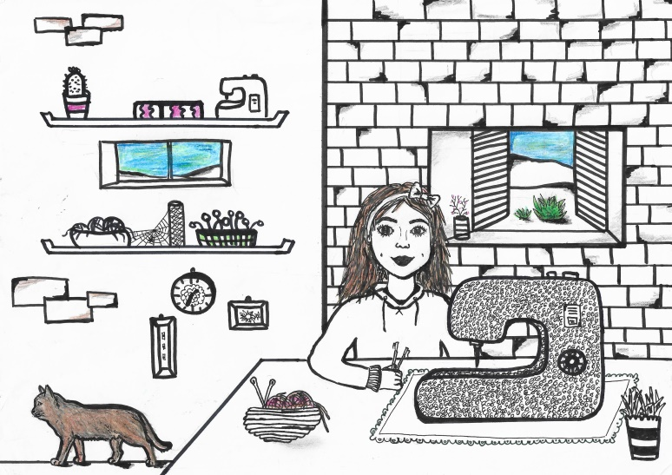
2.
SLO: Povedali smo ji, da poznamo tri različne zgodbe o nastanku imena, vse pa so povezane s turškimi vpadi.
ENG: We told her we know three different legends of the name of the village. However different the legends are, they all have a common origin, namely the Turkish invasions.
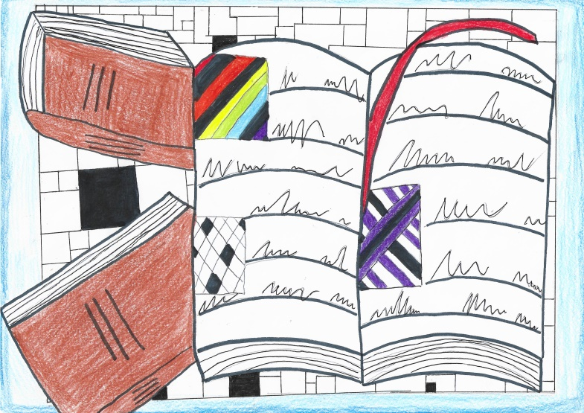
3.
SLO: Prvo je povedal naš sosed.
ENG: The first one was told by our neighbour.
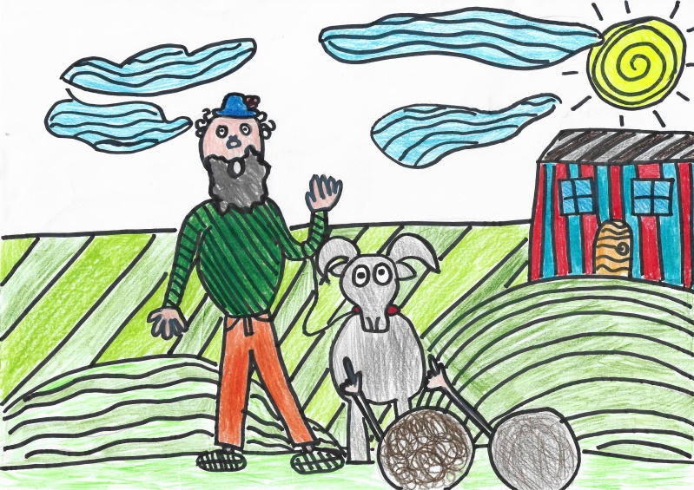

4.
SLO: V vas so na močnih in žilavih konjih prijahali strah vzbujajoči turški janičarji. Požigali so vasi, kradli otroke, živino in živež. Takih napadov so bili deležni tudi v okolici Grosuplja.
ENG: The fearsome Turkish janissary (Turkish warriors) came to the village on strong and tough horses. They were burning villages, kidnapping children, cattle and food. Such attacks occured all around Grosuplje.

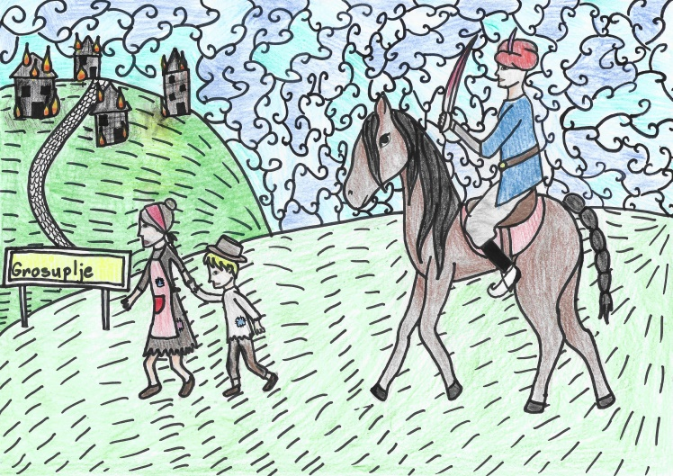

5.
SLO: Nekoč so požgali tudi našo vasico. Zgodil se je čudež, saj je hiša v kateri je živela Jera, ostala popolnoma ne poškodovana. Po tem dogodku je vas dobila ime.
ENG: Once they burnt our village to the ground. But a miracle happened – a house where a woman named Jera lived was left untouched. And that is how the village got its name.
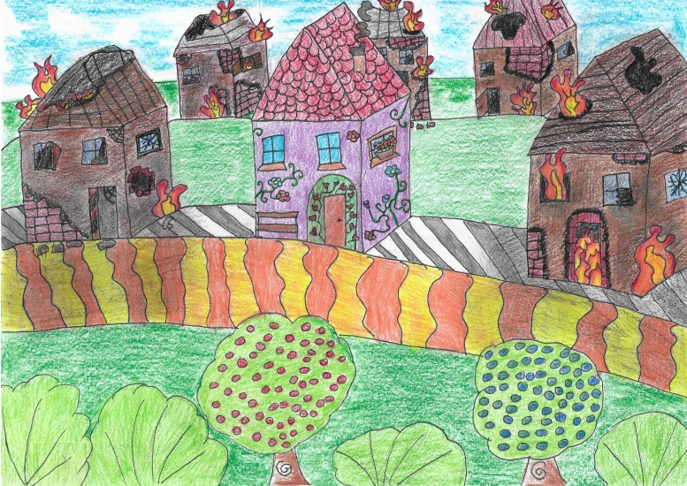

6.
SLO: S tem je pripoved zaključil naš sosed in na vrsto je prišel kmet v ponošenih delavnih hlačah in z vilami ob sebi.
ENG: Our neighbour finished his story … and now it was time for another one. A farmer in shabby working garment and tools in his hands stared talking.
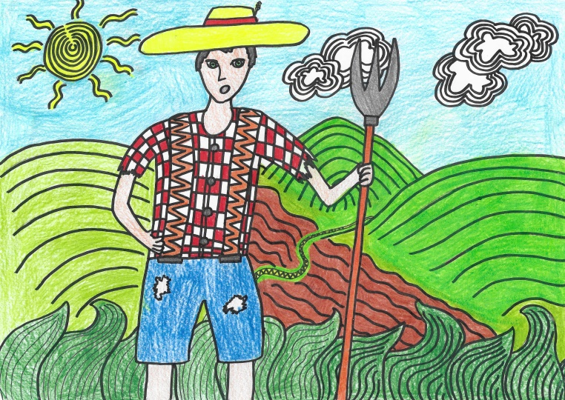

7.
SLO: Povedal nam je, da je Jera na oknu v pinji sušila maslo.
ENG: He told us that a woman named Jera was drying the butter in a special bowl called pinja on the window shelf.
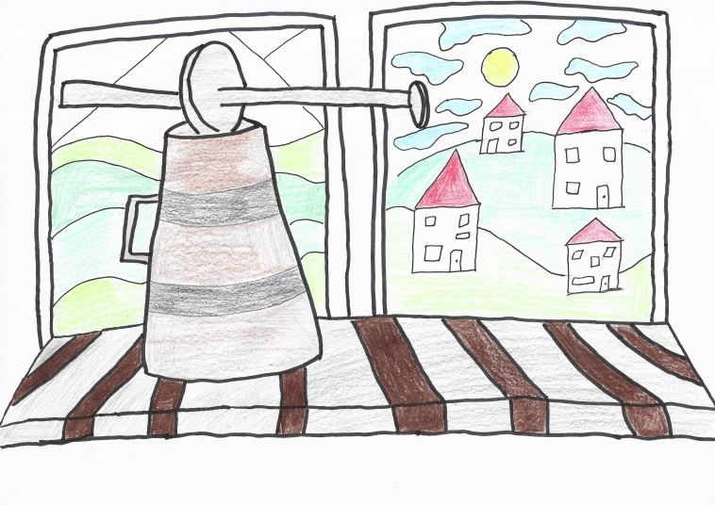

8.
SLO: Turki so mislili, da je pinja top in so se zato raje napotili pustošiti druge vasi.
ENG: Since the bowl was of an unusual form, the Turks thought that thing was actually a cannon. They were afraid they might get hurt so they left to ravage other villages.
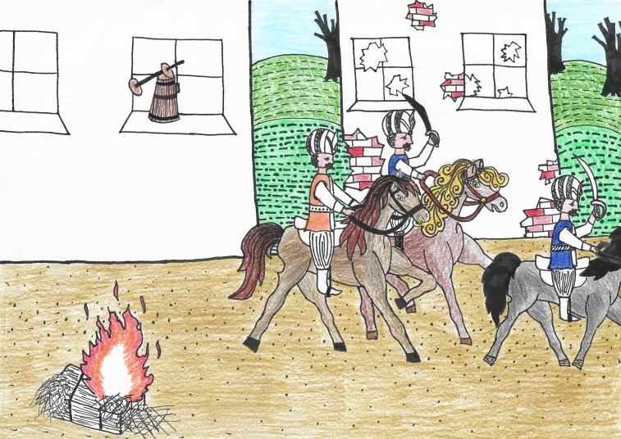

9.
SLO: Najstarejši v vasi je modroval,
ENG: The oldest man in the village said these wise words:
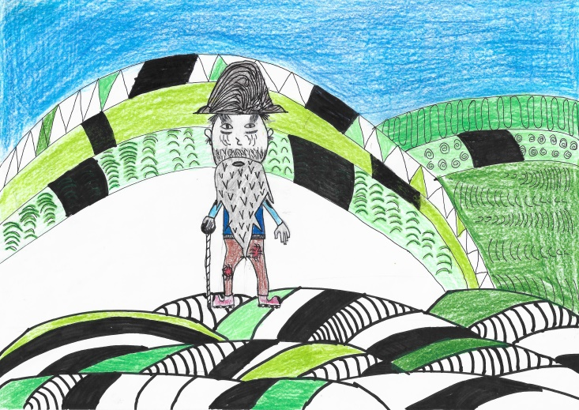

10.
SLO: »Gospodinja Jera je bila zelo pametna, saj se je med napadom Turkov skrila v mlin.«
ENG: »This woman Jera was very smart, since she hid herself into the mill during the Turkish attack.«
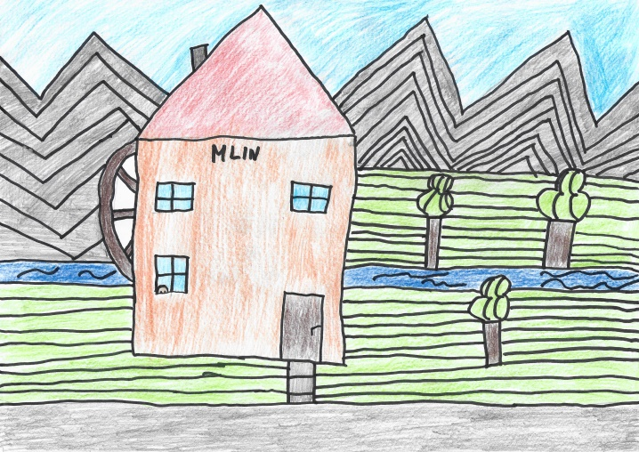

11.
SLO: Ko so jo janičarji našli, so v mlin naredili luknjo in se z glavo naprej tlačili skoznjo, Jera pa je vsakega mahnila po glavi in ga povlekla noter. Tako je vas obvarovala nevarnosti.
ENG: When the janissary found her, they made a hole into the walls of the mill and tried to get inside by their heads first, but Jera punched each of them on the head and pulled him inside one by one. And this is how she protected the village from danger.
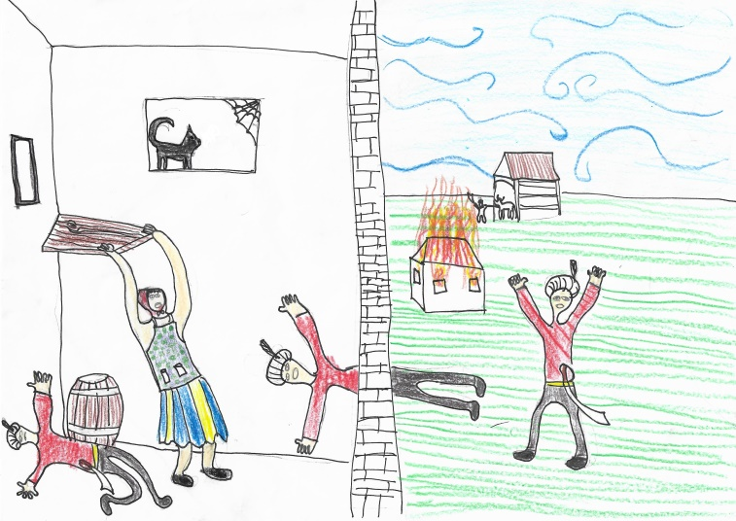
12.
SLO: Ker se je šivilji vas zdela zanimiva, se je vanjo vselila in šivala oblačila za ljudi iz vasi.
ENG: The dressmakes thought she could live in a villeage with such interesting history so she stayed and sewed clothes for the villagers.
